README

1. Implement template class CourseArray<TCourse> in CourseArray.h file. Because this is a template file, all implementation is in header file, no need for CourseArray.cc. The other classes which use normal CourseArray class will have to change as well by binding class Course to CourseArray. For example in class UImanager: void getCourseArray(CourseArray<Course> &, int )

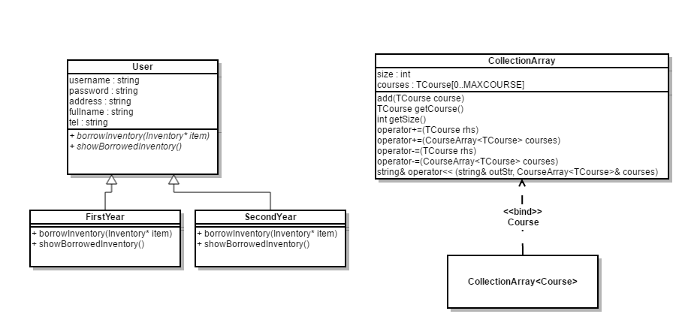

1. Implement polymorphism with new classes and new features

New classes:



New features:

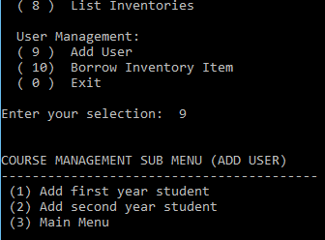

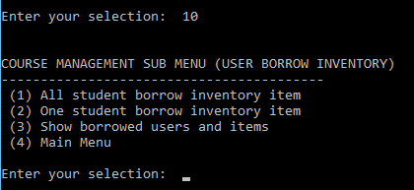

1. Add user: Add user to system, there are 2 types of users: 1st year student and senior year student
2. Student can borrow items, each type of user can behavior differently by borrowing: 1st year student can borrow only 1 item, senior year student can borrow 2 items. The polymorphism is presented in a way that when choose the feature (1) of sub menu borrow inventory, all user instances will call the method borrowInventory corresponding to its type.
3. Classes support polymorphism: abstract class **User** with 2 virtual functions borrowInventory and showBorrowedInventory. 2 concreate classes **FirstYear** and **SeniorYear** which implement these 2 functions. Class **BMScontrol** which has array of User’s instances and call borrowInventory method of these instances